Copyright & the Creative Commons Name____________________

Use the site https://creativecommons.org/about to learn about Creative Commons Licenses. Answer the questions below:

- What is the purpose of Creative Commons licensing?

- Who can use Creative Commons licensing?

- Click on the Licenses tab. Describe in your own words what each license means.

  - Attribution:

  - Attribution-No Derivatives:

  - Attribution-Noncommercial-ShareAlike:

  - Attribution-ShareAlike:

  - Attribution-Noncommercial:

  - Attribution-Noncommerical-NoDerivatives:

- Match the Creative Commons symbol to what it means:
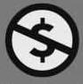
- _____ Attribution a.
- _____Share Alike b.
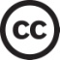
- _____No Derivatives c.
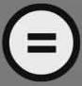
- _____Non commercial d.
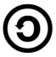
- _____Creative Commons licensing e.

