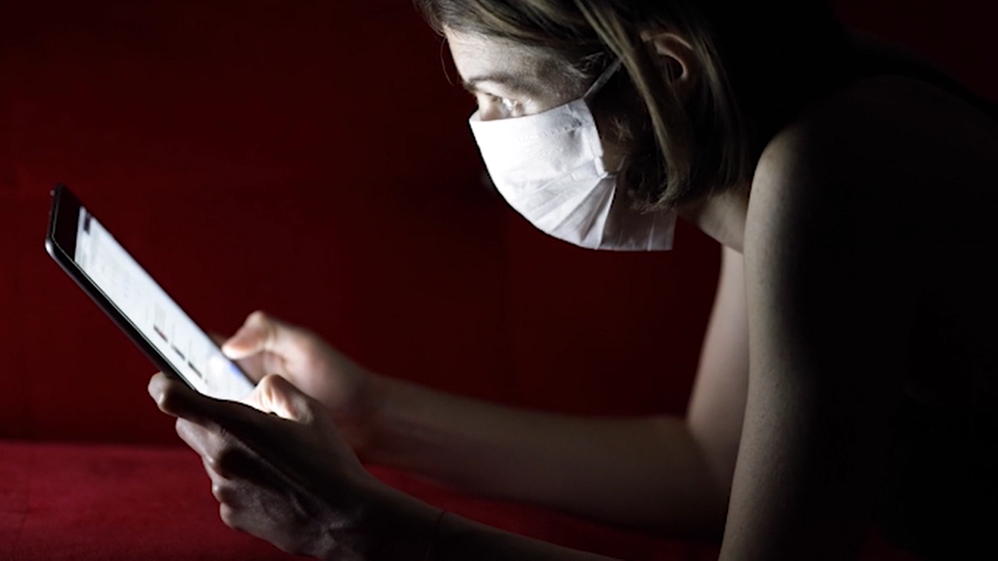

**USER REVIEW**

I like this movie. It seems well made. I enjoyed the part with the person in the corner with a mask on watching all the events happen. The music goes along with it really well. I think showing the events that happened before quarentine helps show what we’re missing and why it’s importat to follow the rules of quarentine. 10/10- would suggest this film. -Cedar

**STORYLINE**

We are living in uprecidented times with a global pandemic haunting all of us. Our routines have been altered and connections with others made more distant. This short informational video reminds us all in a heartfelt way that while we must stay apart for health reasons, we can be together in mind and spirit.

A poetic status update on life in Covid-19 times.

**EDITOR:** Mr. Hermanet

**POET:** James Parker

**SOURCE**

**MATERIAL:**  Pixabay.com, Pexels.com, Videezy.com, Unsplash.com, & Bensound.com

**Ode to Social Distancing**

PG | 2m 6s | Documentary | May 11, 2020