Programming: Writing Classes Practice Name:

- Create a heading for a method that takes 2 words and returns the longer of the two. You do not need to create the body of the function. Here’s the format it should be in generically:

Visibility return_type function_name (data_type formal_parameter, data_type formal_parameter…)

public String longestWord(String word1, String word2)

- Create an object of class type Color that is called blue and that holds the contents “H20”. Again, you do not need to create any functions here. The format should follow this generic layout:

Class_name object_name = new class_name(actual_parameter, actual_parameter…);

Color myColor = new Color(“H20”);

- Considering the object you created in #2 above, call the function returnContents from that object. Assume the function definition is outside the program with the main method in it.

myColor.returnContents( );

- Below is a class called Pet that has 3 variables, 2 methods, and a constructor.

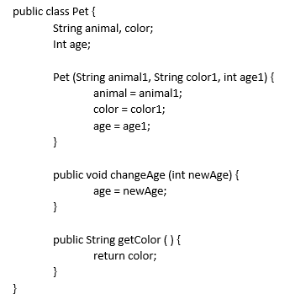

- Create an object of the Pet class called myPet with initial variables set t “Dog”, 6, and “Brown”.
Pet myPet = new Pet (“Dog”, “Brown”, 6);
- Call the changeAge method, resetting the age to 7.
myPet.changeAge(7);
- Use the getColor method to print the color of the Pet object you created in letter a above.
System.out.println(myPet.getColor( ));

